**ES2015 modules**

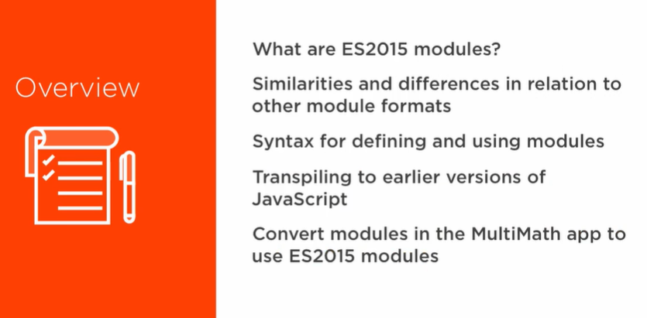

**What are ES2015 modules? How do we create and load them?**

Unlike AMD or CommonJS, they’re natively implemented modules, added well after the others were added by third parties. No loader required. Very similar to the others:

* encapsulate implementation details
* explicitly expose a public API
* support for dependency management

Note that we sometimes need to **transpile** (convert from one language to another) from the modern JS to an older version because older browsers can fail to support our new module syntax.

1. Write modern ES2015 modules.
2. Transpile those modules down to an old version (AMD, CommonJS, etc) with Babel.
3. Load those translated modules with RequireJS or SystemJS

